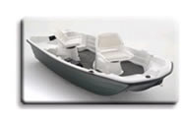
  Thermoforming
  Successful Applications

Our thermoforming materials are proving their value in a broad range of industries, from boating, to construction equipment, to recreational vehicles. For more information on how integral color, weatherability, impact resistance, or a high-gloss surface might make an economic or performance difference in your application, click on one of the examples below.
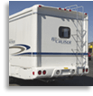 | 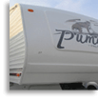 |  | 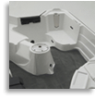
RV end panel | Fifth-wheel front cap | Shipping pallet | Bass boat
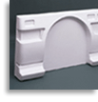 | 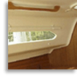 | 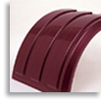 | 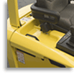
Camper end-cap | Marine cabin headliner | Trailer fender | Fork-lift deck
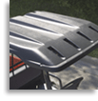 | 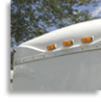 |  | 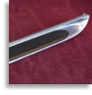
Tractor roof | Trailer front panel | Marine instrument panel | Running board
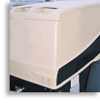
Air compressor cover

